01.09. 2020 Задание по английскому языку для 31Э
Тема 1. Введение в технический перевод Урок 1. Введение в технический перевод
Ответ оформите в документе Word и отправьте по адресу 7ninasun@gmail.com
- Переведите текст и откорректируйте перевод, переводчик иногда переводит неправильно!
Слова к тексту:
circuit | [ˈsəːkɪt] | цепь, контур
conductor | [kənˈdʌktə] | проводник
function | [ˈfʌŋkʃn] | назначение
difference | [ˈdɪfrəns] | разница
open |  | обрыв
short |  | короткое замыкание
trouble | [ˈtrʌbl] | повреждение
no | [nou] | никакой, нисколько
to reduce | [rɪˈdjuːs] | сокращать
to supply | [səˈplaɪ] | снабжать
to connect | [kəˈnekt] | связывать
to compare (with) | [kəmˈpɛə] | сравнивать (с)
to pass through | [ˈpɑːsˈθruː] | проходить через
To result in |  | приводить к, иметь результатом
To result from |  | следовать, проистекать из
Current (I) | [ˈkʌrənt] | электрический ток
Resistance (R) | [rɪˈzɪstəns] | сопротивление
Voltage (V) | [ˈvoultɪdʒ] | вольтаж, напряжение
to suppose | [səˈpouz] | предполагать
law | [lɔː] | закон

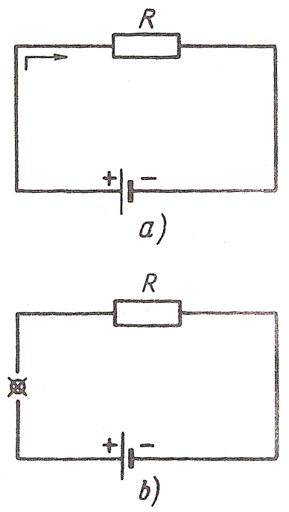
Electric Circuit
This is a circuit. Its elements are a voltage source, a resistor and a conductor. The circuit consists of a voltage source, a resistor and a conductor. A voltage source supplies current. A resistor reduces current. A conductor connects the elements of the circuit.
Compare circuit a with circuit b. What is the difference between them? Current passes through circuit a while no current passes through circuit b. Circuit b has an open. No current through circuit b results from an open. An open and a short are troubles in a circuit. A trouble in a circuit may result in no current in it.
Fig. 1

- Complete these sentences, using the correct variant:
Выберите подходящий вариант, например: 1-а
1. Circuit a consists of | a) resistors and conductors.  b) a voltage source and resistors.  c) a voltage source, a resistor and a conductor.
2. A voltage source | a) conducts current.  b) reduces current.  c) supplies current.
3. A conductor | a) connects the elements.  b) supplies voltage.  c) conducts current.
4. A resistor | a) connects the elements.  b) supplies current.  c) reduces current.
5. No current results from | a) an open.  b) a short.

- Answer the following questions:
Ответьте на вопросы
1. What elements does a circuit consist of?
2. What is the function of a voltage source?
3. What is the function of a conductor?
4. What is the function of a resistor?
5. When is there no current in a circuit?
6. What does an open or a short result in?
7. What does no current in a circuit result from?

- Solve these problems:
Запишите решение, например: 1. 5 × 10 = 50 V
1. How much is the current in the circuit if a 60-volt source is connected to a resistance of 1,600 ohms?
2. How much is the voltage in a circuit having a current equal to 25 amp, if a 25-ohm resistance is connected to it?
3. A 70.35-ohm resistance is connected to the circuit. How much is the voltage if the current equals 4.5 amp?

