Занятие от 2 сентября, 3 пара по расписанию, группа 22Э, преподаватель Самолюк И.Ю.

Тема урока «Соединённое Королевство Великобритании и Северной Ирландии»

Ребята, поздравляю вас с началом учебного года!!!
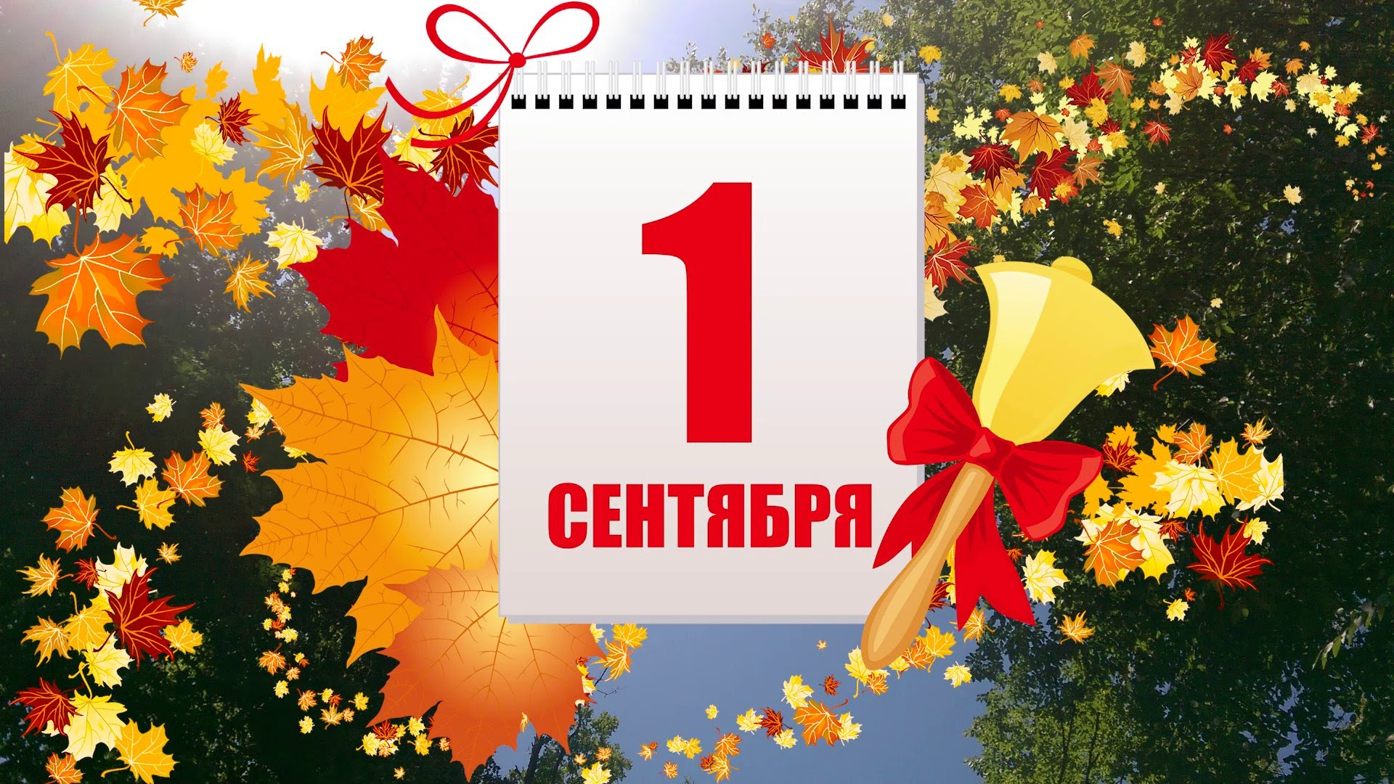

Мы продолжаем изучение курса английского языка. И в этом году нас ждет 72 увлекательных часа английского языка по разделам «Страноведение» в 1 семестре и «Электротехника» во 2 семестре.
В конце учебного года будет дифференцированный зачет , и вы получите годовую отметку в зачетную книжку!
Можете продолжать работать в прошлогодней тетради, если в ней достаточно места или завести новую на 48 листов.

И мы с вами начинаем изучение страны Великобритании.

1. Подумайте, с чем у вас ассоциируется страна Великобритания? Что первое всплывает в памяти. Запишите ответ в тетради на русском языке.
Начните запись в тетради с написания темы урока и не забудьте указать на каждом листе тетради свою фамилию, группу и дату!

2. Предлагаю посмотреть небольшой видеофильм об этой увлекательной стране. Если у кого то не открывается видео или не загружается, переходите к следующему пункту.

3. Изучите содержание текста Great Britain устно.

Great Britain
The official name of Great Britain is. The United Kingdom of Great Britain and Northern Ireland.Great Britain is an island country. It is situated on the British Isles in the northwest of Europe. The English Channel 18 miles wide separates it from France. Great Britain is separated from Belgium and Holland by the North Sea, and from Ireland by the Irish Sea.
Parts of Great Britain
The United Kingdom of Great Britain consists of four parts: England, Wales, Scotland and Northern Ireland. England, Wales and Scotland occupy the territory of Great Britain and Northern Ireland is situated in the northern part of Ireland. The territory of the United Kingdom is about 244 000 (two hundred and forty-four thousand) square kilometres. The population is over 56 million. The capital is London.
The surface of the United Kingdom varies greatly. The northern and the western parts of the country are mountainous and are called the Highlands. All the rest is a vast plain that is called the Lowlands. The mountains are not very high. The rivers are not very long. The most important of them are the Severn and the Thames. There are many beautiful lakes in the mountainous part of the country.
No part of England lies more than one hundred miles from the sea. The coast line has a number of fine bays and excellent natural harbors. World famous ports include London, Liverpool, Bristol, Plymouth, Southampton, Portsmouth, Dover and others.
Climate in Great Britain
The climate of Great Britain is mild the whole year round. The mountains, the Atlantic Ocean and the warm waters of the Gulf Stream influence the climate of Great Britain. Winters are not cold and summers are not hot. October is usually the wettest month, July — the hottest, and January — the coldest.
British Economy
Great Britain is a highly developed industrial country. It is known as one of the world’s largest producers and exporters of iron and steel products, machinery and electronics, chemicals and textile. One of the chief industries is shipbuilding.
Great Britain is a country with old cultural traditions and customs. The most famous educational centres are Oxford and Cambridge universities. They are considered to be the intellectual centres of Europe. The education is not free, it is very expensive.
British Political System
The United Kingdom is a monarchy and the Queen is the head of the state. But in practice it is ruled by the elected government with the Prime Minister at the head. The British Parliament consists of two chambers: the House of Lords and the House of Commons.
There are three main political parties in Great Britain: the Labour party, the Conservative party and the Liberal party.

4. Ответьте на следующие вопросы по содержанию текста на англ.языке. Переведите ответы на русский язык:

- What goods does the British industry produce?
- What is the official name of Great Britain?
- Where is it situated?
- What parts does it consist of?
- What is the territory and the population of Great Britain?
- What city is the capital of Great Britain?
- What is the surface of the country?
- What big industrial cities are there in Great Britain?
- Are there any big rivers and lakes in Great Britain?
- What is the climate on the British Isles like?
- Are there any big educational establishments in Great Britain?
- Is Great Britain is a constitutional monarchy?
- What is the name of the Queen of Great Britain?
- How many chambers does the British Parliament consist of? What are they?
- Is Great Britain a highly developed industrial country?
- What outstanding people of Great Britain do you know?
- What are the main political parties in Great Britain?

! Выполненные письменно задания отправить на проверку по почте: irinasamolyuk@yandex.ru
В теме письма указать Фамилию Имя, группу, дату задания по расписанию

