Занятие от 5 сентября, 1 пара по расписанию, группа 21ТО, преподаватель Самолюк И.Ю.

Тема урока «Мои летние каникулы»

Ребята, поздравляю вас с началом учебного года!!!
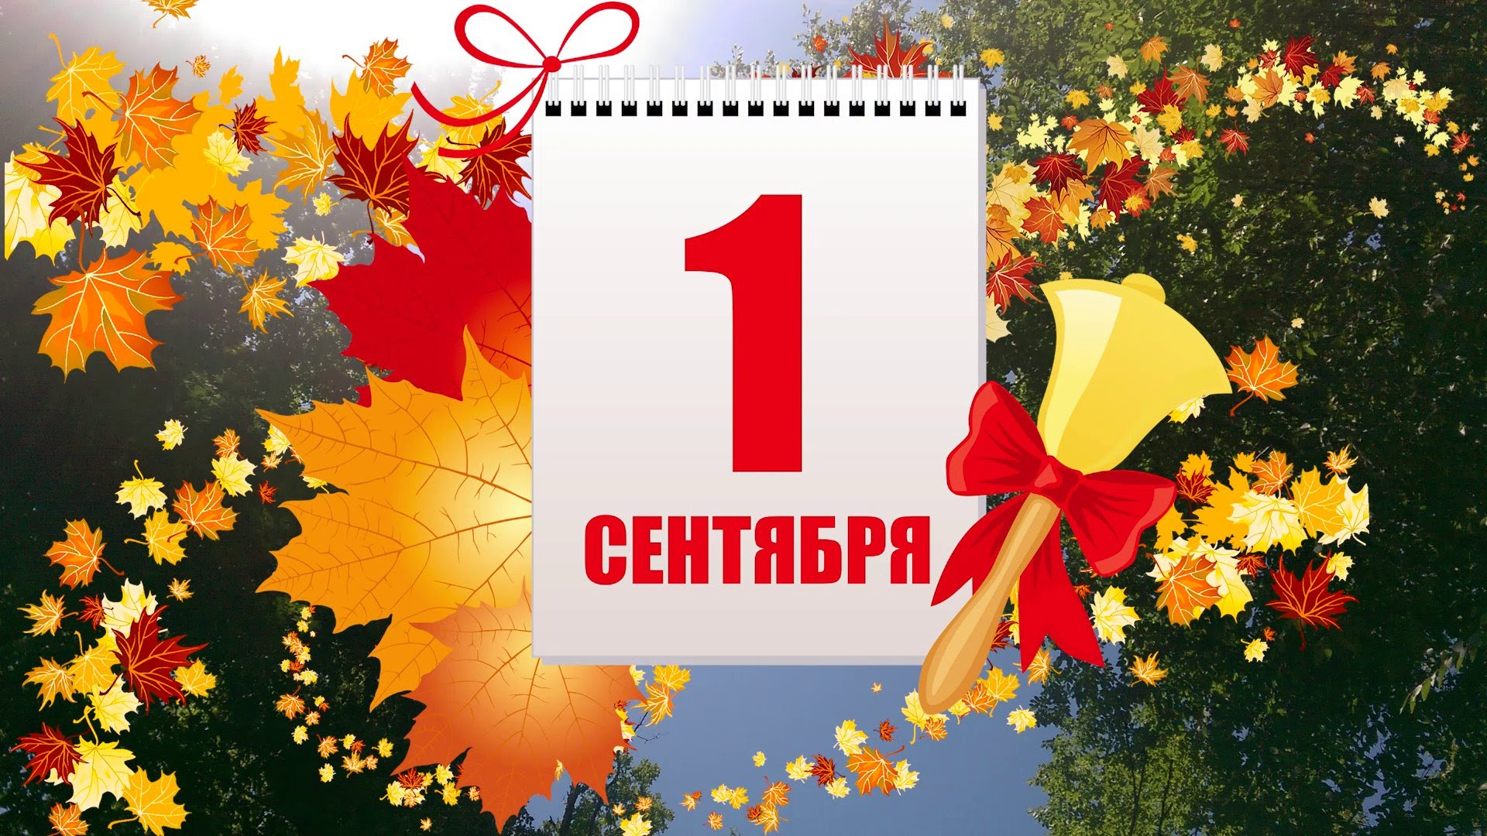

В этом году английский язык у подгруппы, которая занималась у Чухаревой У.П., английский язык буду вести я – Самолюк Ирина Юрьевна!
И в этом году нас ждет 70 увлекательных часов английского языка по разделу «Страна изучаемого языка».
В итоге, в конце учебного года будет дифференцированный зачет, и получите годовую отметку!
Для занятий вам потребуется тетрадь 48 листов.

В тетради обязательно указываем дату и тему урока. На каждом листе тетради вверху должна быть указана ваша фамилия и группа. Не подписанные листы тетради проверяться не будут!!!!!

Итак, записываем Фамилию, группу, дату 5 сентября и тему урока, которая указана вверху. И переходим к содержанию урока:

1. Holidays are always great. During holidays young people have free time to do what they want and just relax.
Summer is the best season for it. Today we are going to read the text about different ways of holiday-making and discuss it.

2. Read the text: Изучите содержание текста устно
«My summer holidays»
Summer is the most wonderful time for holidays. I always look forward to my summer vacations. There are different ways of holiday-spending and you can vary it. You can stay at home sleeping off, reading interesting books, watching TV or playing computer games all day long.
Some people spend their holidays at the seaside or in the mountains.You can also spend several weeks in the country walking through the green fields, watching the clouds and enjoy a nice smell of flowers sitting down on a soft meadow. It’s nice to go for walks to the forest picking mushrooms and berries. If you do not mind of listening to the barking of the dogs and the croaking of the frogs in the evening, go to the country.
Some people want to visit some exotic place like China or Vietnam going sightseeing and visiting the places of interest.
To my mind if your idea of a holiday is something relaxing have a camping holiday.
Our company annualy spends summer holidays on the coast of the Japan sea.We place a tent in a quiet picturesque place on the sea shore for several weeks.We are not afraid of mosquitoes, damp,typhoons and wind. We enjoy fresh sea air and sun all day long. I never get bored there. As a rule I make new friends when I am on a holiday. In the daytime we play volleyball, go fishing and boating, swim in the warm water of the sea, sunbathe, read magazines, newspapers.I like to walk along the beach collecting beautiful shells and interesting pebbles.
In the evening I like to sit on the beach watching the rise and the fall of the waves and enjoying the sunset. Our company finds great pleasure in making bonfires and cooking barbecues. We like to sit around the camp fire telling anecdotes, funny stories and singing to a guitar. At night everyone sleeps except me. I enjoy being alone and observing the sky. The night stars attract me so much that I don’t notice anything else. Later it’s nice to sleep in a tent in your sleeping-bag listening to the noise of the waves.
On this sort of holiday I get absolutely relaxed. There is nothing better for giving you energy to keep you going through the winter. We return home happy and full of impressions.
3. Make sentences out of the following words. Составьте из слов предложения, запишите их в тетрадь и переведите:
- I, on, to, beach, like, the, rise, sit, the,watching.
- Do, like,telling,to, sit, you, anecdotes, the, around, fire?
- Gives, it, you, to, going, energy, you, through, the, keep,winter.
- Enjoy, sky, the, observing, I, night.
- Been, you, have, camping, ever ?
4. Answer the questions. Ответьте на вопросы письменно в тетради:
- Do you always look forward to your summer holidays?
- What do you usually do if you stay at home in summer?
- Are you fond of travelling?
- What countries would you like to visit?
- Have you ever been in the country?
- What did you do there?
- Do you like camping holiday?
- What do you usually do on the sea shore?
- Are you fond of lying in the sun or swimming ?
- What do you enjoy doing in the evening?
- What is your idea of an ideal holiday?

! Выполненные письменно задания отправить на проверку по почте: irinasamolyuk@yandex.ru

В теме письма указать Фамилию Имя, группу, дату задания по расписанию

