Занятие от 12 ноября, группа 21Э, Англ.язык 2 пара, преподаватель Самолюк И.Ю.

В начале занятия ОБЯЗАТЕЛЬНО подпишите в тетради Фамилию, имя и номер группы.
Потом переходите к теме урока!!!

Тема урока «Британские писатели, поэты и художники»

- Записать в тетрадь новые для вас слова, соединив по смыслу по одному слову из каждого столбика, их перевести и выучить:

Daniel character
desert adventure
Robinson writer
famous Defoe
become pots
main popular
real island
make Crusoe

2. Now you see the photo of Arthur Conan Doyle.
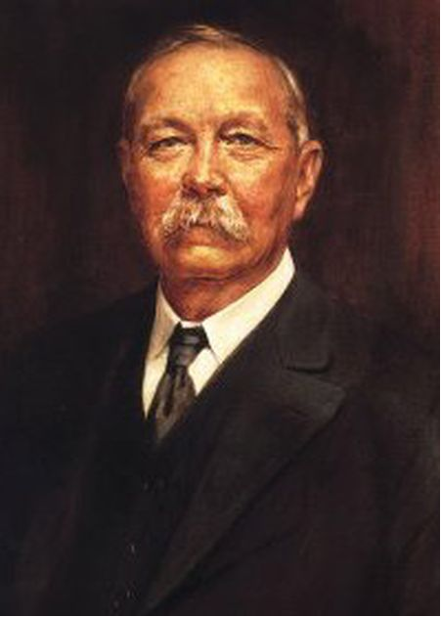

Прочитайте ниже статью про А.К.Дойл. Статья дана в четырех абзацах. Расставьте буквы абзацев согласно плану:
Introduction
(Paragraph 1) - name of person - what famous for
Main Body
(Paragraph 2) - early years (when/where born, education, etc)
(Paragraph 3) - later years (marriage, achievements, etc)
Conclusion
(Paragraph 4) - date of death, comments

A It is surprising that with such a busy life Arthur ['ɑːθə] had time for a family (у него было время на семью), but in 1885 he married Louise [lu'iːz] Hawkins and they had three children. They travelled all over the world until they returned to England because of Louise's poor health. She died in 1906. A year later, Doyle married Jean Leckie and moved to Sussex ['sʌsɪks].
B Most people love the stories about the famous detective Sherlock ['ʃɜːlɔk] Holmes, but not many people can tell you about the man who wrote them. His name was Arthur ['ɑːθə] Conan Doyle.
C Sir Arthur Conan Doyle was a very talented man. His good work and his great books earned him a knighthood ['naɪthud] (рыцарское звание). He died in 1930 at the age of 81.
D He was born in Edinburgh ['edɪnb(ə)rə] on 22nd May, 1859 and was one of ten children. He did well at school, but didn't like it very much. He studied medicine ['medɪsɪn] and became a doctor. As well as a great writer, he was a good sportsman and a keen (отличный) photographer [fə'tɔgrəfə]. He was also interested in things like ghosts [gəust] (духи) and fairies.

3. Ответьте письменно в тетради на следующие вопросы. Не забывайте правила построения предложений в англ языке:
1. Where and when was he born?
2. How did he learn at school?
3. What did he study after school?
4. What was he interested in?
5. What stories did Doyle write?
6. When did he die?

4. По вышеприведенному плану составьте собственную статью про любого известного АНГЛИЙСКОГО писателя, поэта или художника на англ языке.

! Выполненные письменно задания отправить на проверку в течение дня по почте: irinasamolyuk@yandex.ru

В теме письма указать Фамилию Имя, группу, дату задания по расписанию

