**Дата:** 30.09.2020

7-8 уроки

**Группа:** 11 К

**Тема:** Семья и семейные отношения

**Преподаватель**: Дворникова Ирина Анатольевна [dvornikova2283@gmail.com](mailto:dvornikova2283@gmail.com) (до 17 часов в день занятия)

**Задание 1:** Повторить слова по теме «Семья и семейные отношения».

**Задание 2:** Вставьте подходящие по смыслу слова.

1. Your parents’ parents are your ___ and your ___ .

2. Your father’s brother and sister are your ___ and your ___ .

3. Your aunt’s and uncle’s children are your ___ .

4. Your brother’s son and daughter are your ___ and your ___ .

5. Your children’s children are your ___ and your ___ .

**Задание 3:** Посмотрите на картинку и определите, кто есть кто в семье.

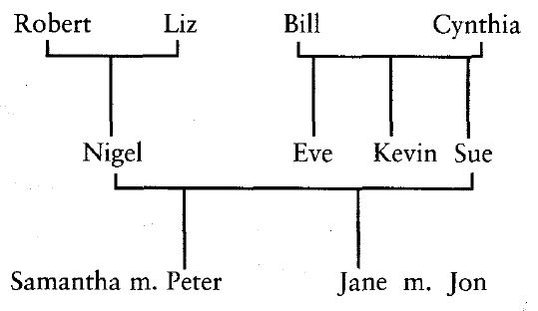

1. Nigel’s mother-in-law is …

2. His father-in-law is …

3. His brother-in-law is …

4. His sister-in-law is …

5. His son-in-law is …

6. His daughter-in-law is …

**Задание 4:** Соедините начало предложений и их конец.

1. We’re not planning to start …  
2. They help us take care of …  
3. We adopted …  
4. We share …  
5. She might want to find …

a. … the house with my wife’s family.  
b. … a baby from China.  
c. … her real mother one day.  
d. … the children.  
e. … a family just yet.

**Задание 5:** Вставьте в предложения следующие слова и фразы:

*the whole family  
a very close family  
a big family  
family tree  
a big family reunion*

1. I come from … . I’ve got four brothers and two sisters.

2. We’re … . We see each other almost every day and if ever I’m in trouble, I know I can turn to one of them for help.

3. It’s my son’s eighteenth birthday next week. We’re hoping to get … together.

4. My wife and I are celebrating our 40th wedding anniversary soon. We’re planning to have … .

5. When I was researching my … . I found out that my great-great-grandfather came over to England from Ireland 120 years ago.