**Дата:** 26.10.2020

5-8 уроки

**Группа:** 11 К

**Тема:** Описание человека (внешность, национальность, образование, личные качества, профессия).

**Преподаватель**: Дворникова Ирина Анатольевна [dvornikova2283@gmail.com](mailto:dvornikova2283@gmail.com) (до 17 часов в день занятия)

**Задание 1:** Повторить слова по теме «Описание внешности».

[http://englishinn.ru/appearance-ili-kak-opisat-vneshnost-na-angliyskom-yazyike.html](http://englishinn.ru/appearance-ili-kak-opisat-vneshnost-na-angliyskom-yazyike.html%20)

**Задание 2:** Соотнесите описания людей с их изображениями:

1. He isn’t very tall. He’s short and stocky.  
2. She’s tall and slim. She’s got a lovely figure.  
3. He’s quite a big guy. He’s quite well-built.  
4. She’s a bit overweight. She’s quite plump, isn’t she?  
5. He’s very fat. He’s absolutely enormous.  
6. He’s very thin. He’s so skinny.

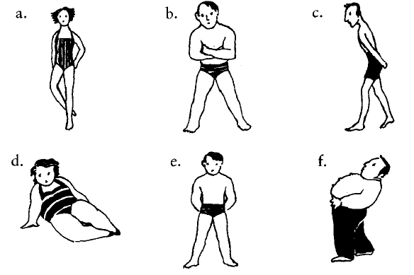

**Упражнение 2.** На картинках даны отрывки текстов. Соотнесите отрывки (под буквами) с их источниками (под цифрами).

1. An extract from a novel.  
2. An extract from a newspaper report.  
3. An extract from the Guinness Book of Records.  
4. An advertisement in a lonely hearts section of a newspaper.

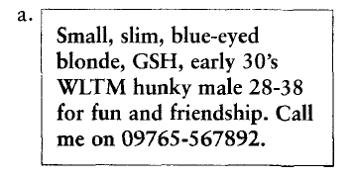

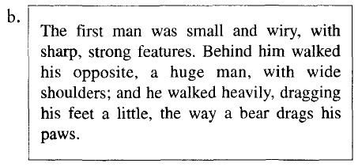

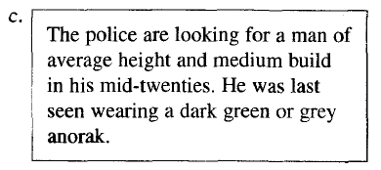

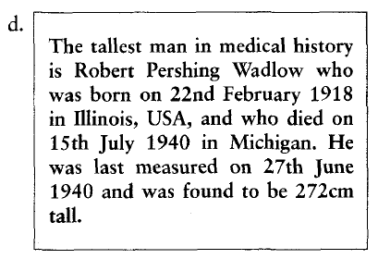

**Упражнение 3.** Поставьте в предложения следующие словосочетания:

long nails  
big feet  
lovely complexion  
hairy chest  
bad skin  
deep voice  
long legs  
thin legs

1. Size 12! Are these your shoes? You’ve got _______ , haven’t you?

2. You’ve got such _______ . Would you like to move the seat back a bit?

3. I’ve never seen you in shorts before. You’ve got such _______ . You should go running and try to build up them up a bit!

4. My boyfriend’s got a really _______ . It’s like being with a gorilla.

5. You’ve got such lovely _______ . Are they real?

6. He’s got such a _______ . I find it very sexy when he speaks to me on the phone.

7. Keith’s new girlfriend must spend a fortune on face cream to have such a _______ .

8. Poor Tim. He’s had really _______ since he was 13.

**Упражнение 4**. Вместо пропусков поставьте данные в скобках слова.

1. He’s a _______ , _______ man with _______ , _______ hair.  
(short, tall, fair, good-looking)

2. She’s a _______ , _______ woman with _______ hair.  
(tall, long, thin)

3. I’ve got _______ , _______ hair and I’m tall and very _______ .  
(thin, straight, black)

4. She’s very _______ with a _______ tan and _______ _______ hair.  
(blonde, lovely, good-looking, long)

5. I wouldn’t describe my husband as _______ , _______ and _______ ! Short, overweight, and going thin on top is more accurate!  
(handsome, dark, tall)

**Упражнение 5.** Соотнесите предложения и картинками:

1. The accident left a scar on his forehead.  
2. He’s got a birthmark on his head.  
3. I’ve just had a tattoo done.  
4. He’s got a mole on his back.

