**13.11. 2020 Задание по английскому языку для 21А**

**Урок 10** Достопримечательности Лондона. Выполнение послетекстовых упражнений

**Ответ оформите в документе Word и отправьте по адресу** [**7ninasun@gmail.com**](mailto:7ninasun@gmail.com)

1. **Переведите текст и откорректируйте перевод, переводчик иногда переводит неправильно!**

You’re never short of things to do in London. The city is packed with galleries, museums and monuments which attract visitors from across the globe. But these iconic sights aren’t just for tourists; we think that locals and daytrippers alike should tick these off their bucket list.

1. Houses of Parliament – Best London Sightseeing Place 2020 UK

If you are a visitor and you want to witness the debates that are happening at the House of Lords then you are more than welcome. You can go to houses of parliament in London sightseeing tour and see the live debates in House of Commons and the house of Lords. On Wednesday, Prime Minister is present at the House of Parliament and the questioning session starts at noon on Wednesday. If you want to see how great nations question their Prime Ministers then this is the perfect place for you to be. However you should keep in mind that tickets should be arranged in advanced by your embassy for you.

[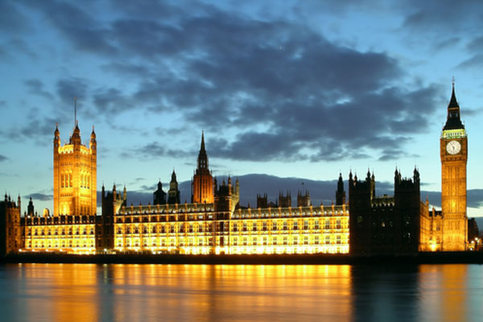](http://londonbeep.com/wp-content/uploads/2013/11/houses_of_parliament_london.jpg)

2. National Gallery, London 2020 UK

If you have kids and you are living in London city then you would definitely want your children to learn about the cultural heritage of your city. For this purpose, you can take your kids to National Gallery which is one of the biggest London sightseeing destinations for families. There is also a two hour art workshop arranged for kids within the age group of 5 to 11 years and that workshop takes place on Sundays from 11am to 1pm and 2pm to 4pm. If your children are between 6 to 12 years of age then you should try the imaginative family workshop that takes place from 2pm to 3.30pm on each Saturday.

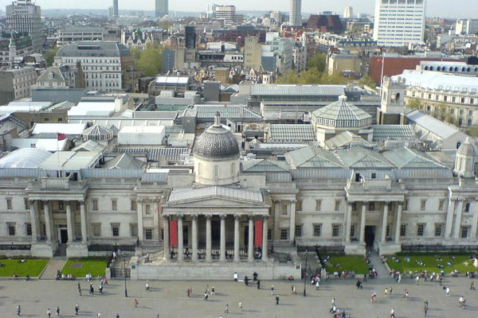

6. Buckingham Palace – Best London Sightseeing Places 2020 UK

If you visit London but you don’t go to Buckingham Palace then your tour isn’t completed yet. That is the main reason why this London sightseeing destination is at number one in our list. This is also Queen’s official residence as well. We know that Buckingham Palace is not the fairy-tale type of destination but this still remains one of the “most popular places in UK” and entire world. There are a total of 19 rooms that are open for public but you will have to reach there from July to October each year. There are some other Royal Palaces where you must visit and that include; Eltham Palace, Hampton Court Palace and Kensington Palace.

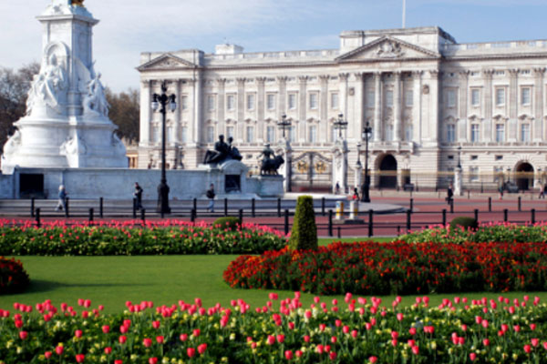

**2. Ответьте на вопросы STUDENT’s QUESTIONS**

|  |  |
| --- | --- |
| 1) | What images spring to mind when you hear the word ‘tourism’? |
| 2) | How important is tourism to your country? |
| 3) | Would you like to work in tourism? |
| 4) | What are the good and bad things about tourism? |
| 5) | What do you think tourism will be like in the future? |
| 6) | What are the major tourist attractions in your country? |
| 7) | What do you think of the idea of space tourism? |
| 8) | How does tourism change lives? |
| 9) | What is eco-tourism? Do you think it’s a good idea? |
| 10) | Is there a difference between a tourist and a backpacker ? |