**Дата:** 10.09.2020

3-4 уроки

**Группа:** 21 К

**Преподаватель**: Дворникова Ирина Анатольевна

[dvornikova2283@gmail.com](mailto:dvornikova2283@gmail.com) (до 17 часов в день занятия)

**Тема:** Лондон – столица Великобритании

**Задание:**

**Задание 1.**Фонетическое упражнение. Прочитайте и переведите (про себя) слова:

***Building, monument, capital, museum, palace, square, stadium, tower, gallery, place, park, street, church, garden, bridge, zoo, cathedral, theatre, cinema***

***Beautiful, fantastic, interesting, famous, favorite, lovely, important, popular, old***

Выпишите слова со звуками:

[æ]

[ ju:]

[ a:]

[ ei ]

[i]

**Задание 2.** *Посмотреть презентацию о достопримечательностях Лондона.* [*https://nsportal.ru/shkola/inostrannye-yazyki/angliiskiy-yazyk/library/2013/03/28/dostoprimechatelnosti-velikobritanii*](https://nsportal.ru/shkola/inostrannye-yazyki/angliiskiy-yazyk/library/2013/03/28/dostoprimechatelnosti-velikobritanii)

*Так выглядит страничка сайта (см. ниже). И сделайте записи о каждой достопримечательности, исходя из информации на слайде, на моем примере. Записываем название на английском языке, перевод и краткую информацию об объекте:*

The Palace of Westminster - Вестминстерский дворец – место, где проводит заседания Британский парламент.

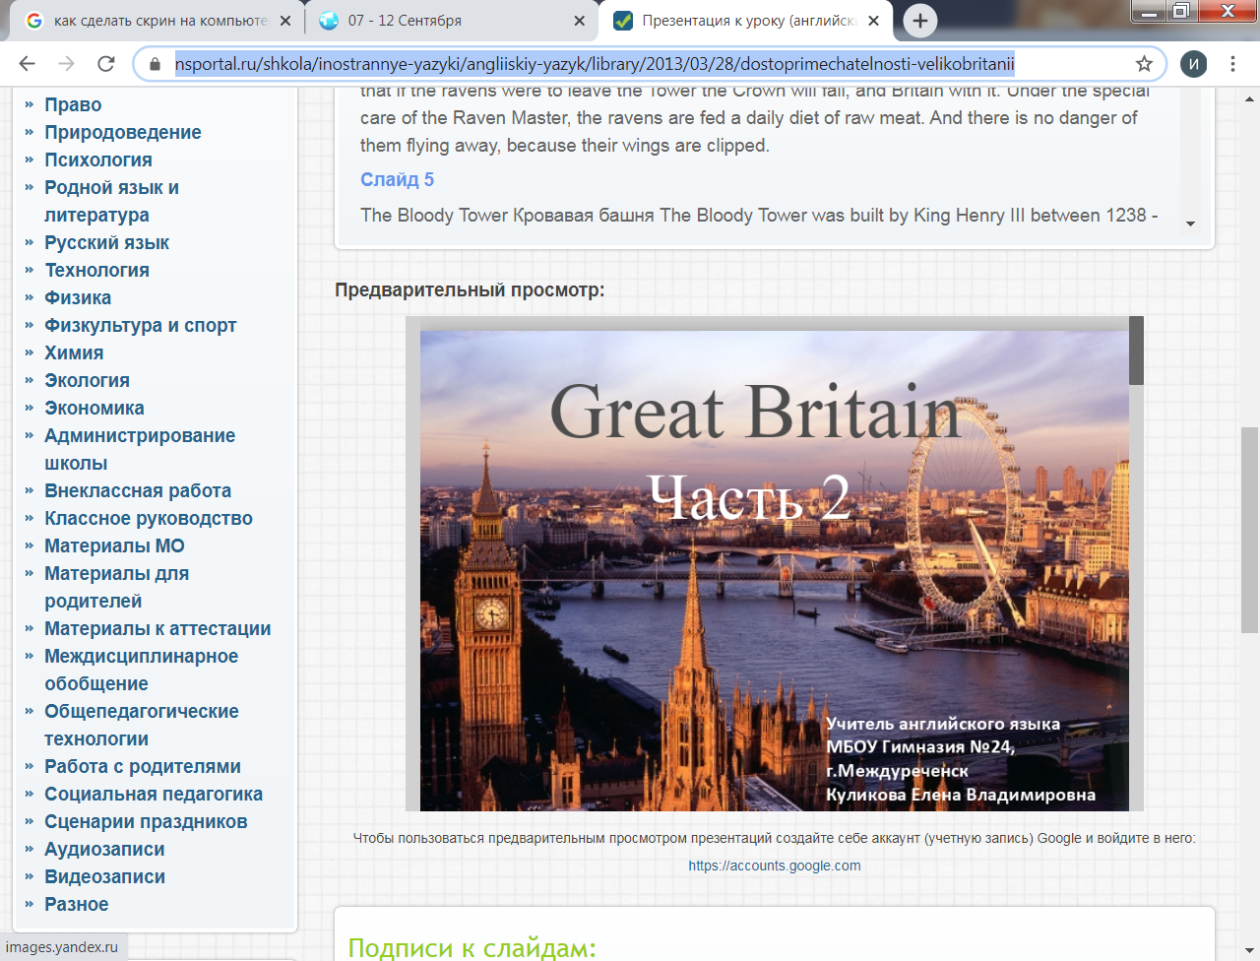

**Задание 3.** *Прочитайте текст и ответьте письменно на вопросы на английском языке!*

London is the capital of Great Britain. It is its political and business center. It stands on the river Thames. Here many years ago Romans built Londinium. Later this town got the name London. A lot of tourists visit London every year. In the center of London there are 4 main parts: The City, Westminster, the West End, the East End.

The heart and the oldest part of London is the City. There are lots of banks, offices and historic places: the Tower of London, Tower bridge, London bridge, St. Paul’s Cathedral. The Tower of London is the oldest building of London. William the Conqueror built it in the 11th century. Many years ago it was a fortress, a King’s Zoo, even a prison! Now it is an interesting museum. St. Paul’s Cathedral is one of the greatest churches of England.

If you want to get to Westminster, go along the Thames or you can visit Trafalgar square on your way. There you will see magnificent Nelson’s Column and the National gallery.

Westminster is the political center of London. There are many political offices. At #10 Downing street the British Prime Minister lives. The British Government works in the Houses of Parliament. Buckingham palace is the official residence of Queen Elizabeth II.

Near Westminster there is the West End. Here rich people live and many museums, parks and shops are situated. Here you can walk in Hyde Park or Regent’s Park. You can visit the British Museum, the National Gallery, Madame Tussaud’s Museum. You can walk along Oxford st., Baker st., Whitehall or see many other interesting places.

**Answer the questions. Find the places in the map**.

1. What is the capital of Great Britain?
2. On what river does it stand?
3. Who built Londinium?
4. What are the 4 main parts of London?
5. What is the oldest part of London?
6. Name some historic places of the City.
7. What is the oldest building of London?
8. Who built the Tower of London? How old is sit?
9. Is the Tower a royal Zoo now?
10. What London bridges can you name?
11. What is one of the greatest churches of England.
12. What can you see in Trafalgar square?
13. What is the political center of London?
14. What political offices are there?
15. Where does the British Prime Minister live?
16. What is in the Houses of Parliament?
17. Where is the official residence of Queen Elizabeth II.
18. What interesting can you find in the West End.
19. What parks can you name?
20. How many London museums can you name?
21. Is Whitehall a house?
22. What London streets do you know?