**19.11. 2020 Задание по английскому языку для 21А**

**Урок 11-12** Достопримечательности Лондона 2. Выполнение послетекстовых упражнений

**Ответ оформите в документе Word и отправьте по адресу** [7ninasun@gmail.com](mailto:7ninasun@gmail.com)

1. **Переведите текст, ПРОЧИТАЙТЕ и откорректируйте перевод, переводчик иногда переводит неправильно!**

**London Attractions & Sightseeing**

London is a remarkable city with a rich and truly limitless heritage upon which to draw. It is no surprise therefore that London has numerous attractions and famous landmarks, from all eras of its history. No matter where you are located within London, there is a never ending list of things to do and places to see.

**The London Eye** is one of London's newest landmarks specially-built to open the 21st century, although it was not open for the New Millennium celebrations as planned.

At 135 metres, it is the tallest wheel of its kind and sits on the South Bank of the

River Thames, opposite the Houses of Parliament. Rotating at a speed of 1 mph, it takes 30 minutes to go through a complete 360°.

People ride the Eye in one of 32 oval-shaped glass bubbles. Famous landmarks visible in the panorama include The Embankment, Charings Cross and Waterloo stations, the Palace of Westminster and Big Ben, Whitehall and many more!

The Eye has provoked other countries to challenge its size. There are plans to build a 175m wheel on the Las Vegas Strip and the Chinese have countered this bid with plans for a 200m wheel in Shanghai.

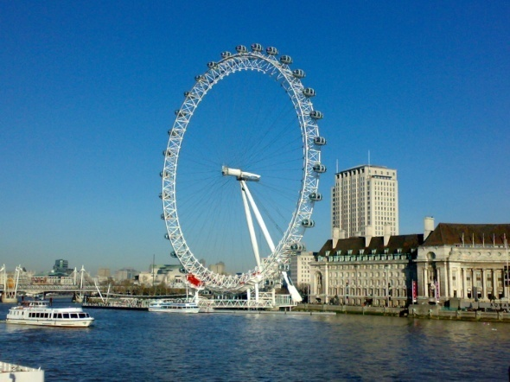

# 2. The Tower of London

More formally known as Her Majesty's Palace and Fortress, the Tower of London is most famously known as a prison and execution site for high-profile criminals, usually accused of high treason. Enemies of the state were brought to it along the Thames, entering through 'Traitor's Gate'.

Key people to be executed here included William Hastings, Anne Boleyn, Catherine Howard, Lady Jane Grey and Robert Devereux.

In the 20th Century executions included 11 German spies captured during WW1.

Elizabeth I was imprisoned in the White Tower during the reign of her sister Mary.

The most recent prisoner was Rudolf Hess was held here for 4 days during WW2.

William the Conqueror ordered it to be built from stone, imported from Normandy, so that it would be able to withstand any attack on London.

Richard the Lionheart then upgraded its defences with a moat.

King John then decided to use it as a Royal Menagerie to house animals from home and abroad. The menagerie was opened to the public in 1804 and thus became London's first zoo until being replaced by the current London Zoo at Regents Park in 1835.

Apart from being a tourist attraction, the Tower is used to guard the priceless Crown Jewels, used to crown sovereigns on their Coronation Day. The guardians of the Tower are famously recognised in their red tunics and black stockings and being known as the 'Beafeaters'.

The Tower is also the home to 7 black ravens which must be fed at the expense of the government. If no ravens reside at the Tower, then the country is believed to be under threat of invasion!

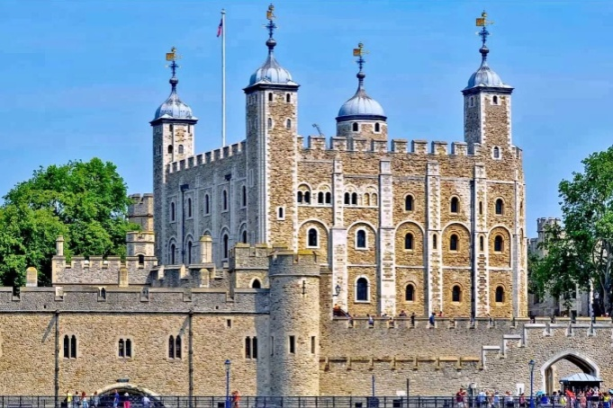

# 3. Trafalgar Square

The statue of Admiral Horatio Nelson, who was buried at St Pauls Cathedral, stands high above the traffic at Trafalgar square. Originally created to commemorate Nelson's famous victory at the Battle of Trafalgar during the Napoleonic wars, the the statue is flanked by four bronze lions said to have been cast from the metal of reclaimed cannons from the French fleet.

Below Nelson, tourists gather to feed the frightening number of pigeons who sweep in and out of the crowds and across to St Martin in the Fields, a church which has been standing since the thirteenth century - worth a visit, especially for its stunning interior. The square is also overlooked by the National Gallery and Admiralty Arch.

It would seem all roads lead to Trafalgar Square, and most cars seem to end up there, in a perpetual traffic jam. Ironically Trafalgar Square is dead in the centre of London and the square is the point from which all distances to locations in the UK are measured. Trafalgar Square has over the decades been a site for protest; from anti-nuclear demonstrations of the 1960's to the infamous 1990 Poll Tax Riots; as well as national celebration: a Christmas ceremony has been held annually since 1947.

If you are planning to visit Trafalgar Square, you are advised to get the tube (Charing Cross) and leave the car behind.

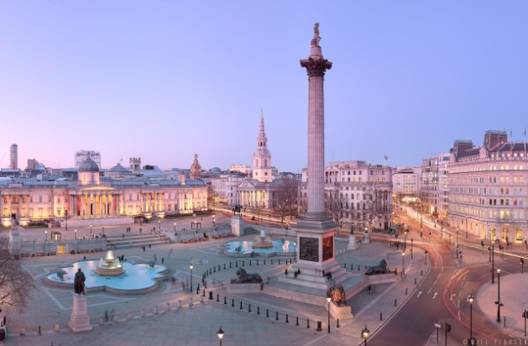

**2. Ответьте на вопросы. STUDENT’s QUESTIONS**

|  |  |
| --- | --- |
| 1) | What springs to mind when you hear the word ‘travel’? |
| 2) | Are you a traveller? |
| 3) | Is travel an education? |
| 4) | Would you like to travel in space or to the moon? |
| 5) | Would you like to work in the travel industry? |
| 6) | What are the pros and cons of traveling first class and backpacking? |
| 7) | Is travel helping the world? |
| 8) | What would make you wiser – travelling around the world for ten years or reading 10,000 books? |
| 9) | Mason Cooley said: "Travelers never think that they are the foreigners." Do you agree? |
| 10) | St. Augustine said: "The World is a book, and those who do not travel read only a page." What does this mean? Do you agree? |

**3.Опишите достопримечательность или ваше любимое место на Урале, которое вы могли бы показать туристам (8-10 предложений)**