**18.11. 2020 Задание по английскому языку для 21М**

**Урок 10** Достопримечательности Лондона. Выполнение послетекстовых упражнений

**Ответ оформите в документе Word и отправьте по адресу** [**7ninasun@gmail.com**](mailto:7ninasun@gmail.com)

1. **Переведите текст, ПРОЧИТАЙТЕ и откорректируйте перевод, переводчик иногда переводит неправильно!**

**Westminster Abbey**

Like the Pantheon Crypt in Paris, where you can see the tombs and memorials to great figures from history, Westminster Abbey is a popular attraction to peruse the graves, tablets, busts and stone dedications. Seventeen kings and queens are buried here, along with dukes, countesses and history’s ‘celebs’ – Darwin, Dickens, Hardy, Behn, Olivier, etc.

Throughout the cloisters and chapels of the Abbey are most than 3,000 souls that have been honoured with stones, statues and shrines. There’s even an entire stained glass window dedicated to Isambard Kingdom Brunel, and a whole corner for poets and creatives in the South Transept, including DH Lawrence, Jane Austen, Dylan Thomas, Lewis Carroll, Shakespeare and many more.

It’s also worth exploring the Abbey’s grounds while you’re there. The gardens are quite beautiful, with four in all: the original Garth, Little Cloister and College Gardens, as well as the more recent addition, St Catherine's Garden. The College Garden is one of the most intriguing, as it is home to the original infirmarer’s patch, which was (and still is) used to grow medicinal herbs and foods for the residents of the Abbey. But of course all the gardens are beautifully presented and surrounded by gorgeous architecture, so any would make for a lovely stroll.

Due to the fact that Westminster Abbey is still a fully functioning church, the visiting times often vary, so check the website first if you’re planning to go down to see which bits will be accessible. If you’re determined on popping by regardless, the Cellarium Café makes for a pleasant spot to stop; it’s typically open weekdays from 8am, Saturdays from 9am and Sundays from 9.30am. It’s also worth noting that audio-guided tours run every day detailing the Abbey’s highlights.

Something new in the works at the Abbey is The Queen’s Diamond Jubilee Galleries, which are set to open in 2018. They’re housed 70 feet above the floor of the Abbey and, until they open once again, have been hidden from the public gaze for over 700 years. Once up there, you’ll get a fab view of the Palace of Westminster and into the church, and be able to see objects and images detailing the Abbey’s thousand-odd-year history.

Westminster Abbey is a magnificent place to hear choral performances, classical concerts and recitals. On Sundays there are free 30-minute organ recitals at 5.45pm and daily there are services as Abbey life continues around you.

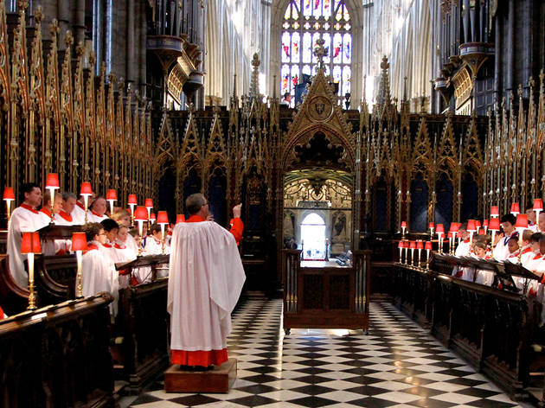

# Tower Bridge

One of the most famous river crossings in the world, Tower Bridge is actually only 123 years old. Still, the fact that it lifts up in the middle when large vessels are passing underneath makes it an icon that most children probably picture in their minds when singing ‘London Bridge is falling down’.

Planes have flown through it, David Beckham has steered a speedboat underneath it and in 1952 a double-decker bus really did ‘leap’ over the gap when the bridge started to lift without warning.

When it was finally finished in 1894 – working having begun in 1886 – Tower Bridge was steam-powered (seriously) and was considered a miracle of Victorian engineering. In 1974 it underwent a transformation, with an electro-hydraulic system installed, but you can still see the old steam engines inside the bases of the towers with a ticket to the Tower Bridge Experience. This also allows entry to the walkways overhead, where you can take in the stunning views, not just up and down the Thames, but of the road below as well. Since 2014 – the bridge’s 120th year – there’s been an 11-metre glass floor in place of the upper walkway, so those with the stomach for it can gaze 42 metres down, or for something special, take part in a morning yoga class.

Besides engines and walkways, your entry fee also includes an exhibition that honours the other awe-inspiring feats of engineering in global bridge design, as well as an art installation as you descend down the ornate staircase.

In peak visiting hours or during bridge lifts it’s not always easy to guarantee what time you will be able to access the walkways, and the bridge lifts actually take place more often than you’d think. Raising Tower Bridge’s two bascules is a service provided free of charge by the City of London Corporation, 365 days a year, night or day, to the relevant registered boats and ships. On average, Tower Bridge is raised 850 times a year, so next time you’re walking nearby, wait and see what happens, as it’s always a treat to see the bridge go up.

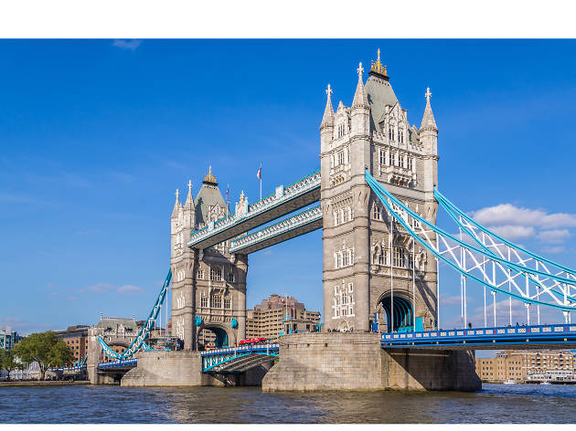

**2. Ответьте на вопросы STUDENT’s QUESTIONS**

|  |  |
| --- | --- |
| 1) | What springs to mind when you hear the word ‘hometown’? |
| 2) | What do you think of your hometown? |
| 3) | Would you like to live in your hometown forever? |
| 4) | What is there to do in your hometown? |
| 5) | What are your happiest hometown memories? |
| 6) | How could your hometown be better? |
| 7) | What is the geography of your hometown? |
| 8) | What are the biggest industries or employers in your hometown? |
| 9) | Is your hometown famous for anything? |
| 10) | What would you do if you were mayor of your hometown? |